**HTTP :-**

[**https://www.youtube.com/watch?v=GTmjthNvrxY&list=PLC3y8-rFHvwgg3vaYJgHGnModB54rxOk3&index=41**](https://www.youtube.com/watch?v=GTmjthNvrxY&list=PLC3y8-rFHvwgg3vaYJgHGnModB54rxOk3&index=41)

[**https://www.freecodecamp.org/news/how-to-use-axios-with-react/**](https://www.freecodecamp.org/news/how-to-use-axios-with-react/)

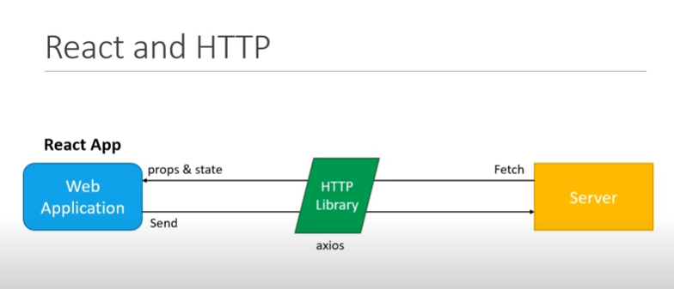

**CREATE REACT-HTTP**

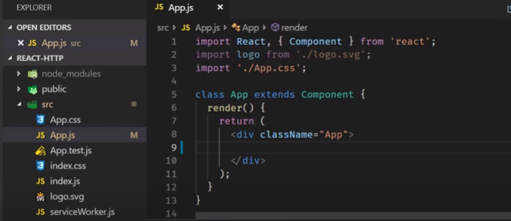

**INSTALL npm install axios**

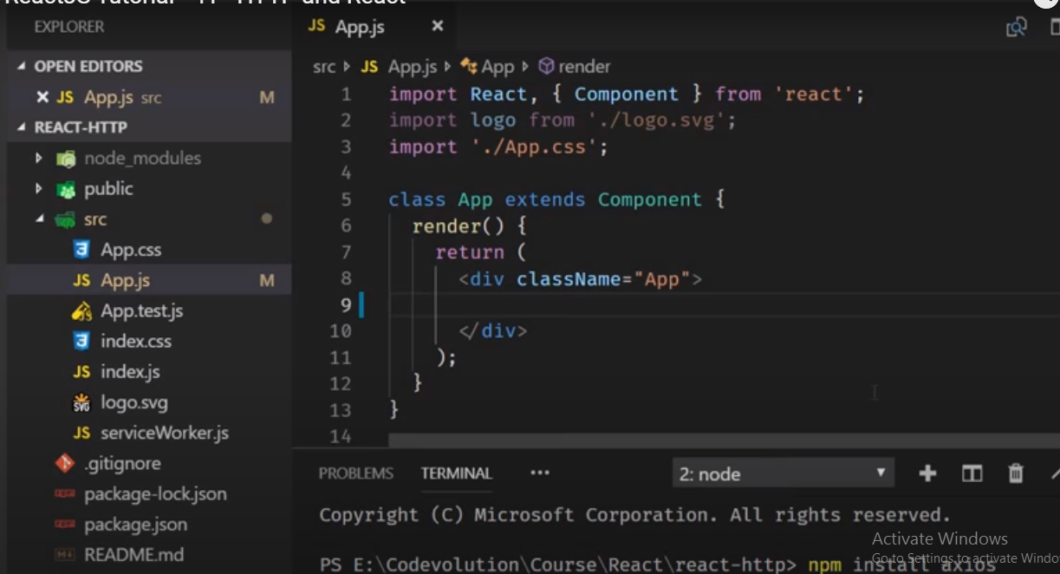

**In package.json**

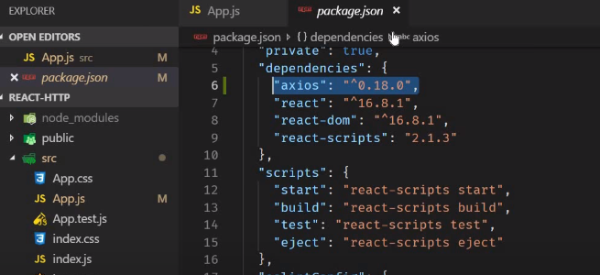

[**https://www.youtube.com/watch?v=NEYrSUM4Umw&list=PLC3y8-rFHvwgg3vaYJgHGnModB54rxOk3&index=42**](https://www.youtube.com/watch?v=NEYrSUM4Umw&list=PLC3y8-rFHvwgg3vaYJgHGnModB54rxOk3&index=42)

**get request : -**

[**https://jsonplaceholder.typicode.com/**](https://jsonplaceholder.typicode.com/)

**scroll the page down**

**code**

[**https://github.com/gopinav/React-Tutorials**](https://github.com/gopinav/React-Tutorials)

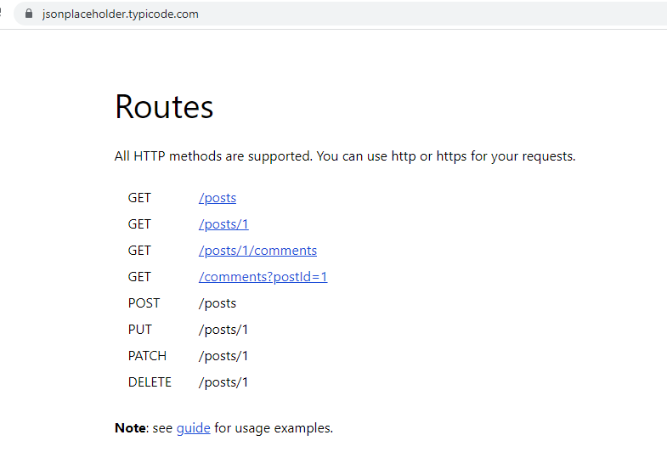

**Create the folder as component – PostList.js**

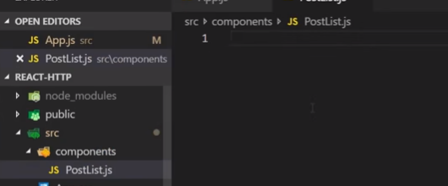

* **Rec – will get below class.**

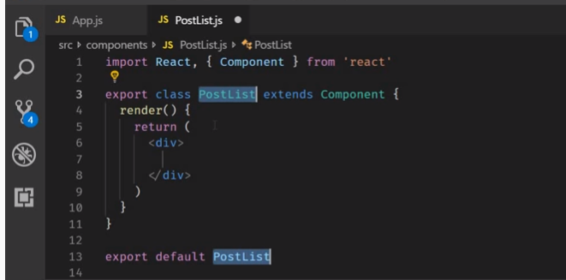

**In post list –remove- export and list of post ..**

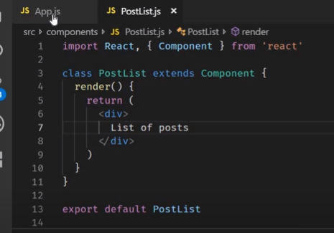

**In app.js**

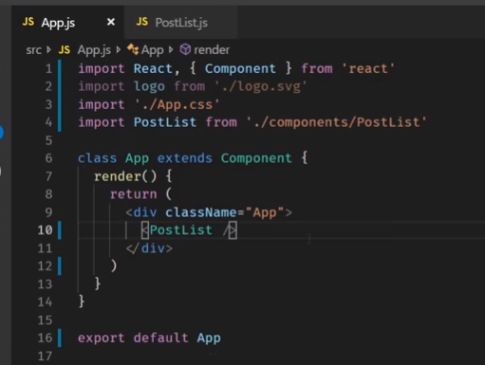

**In browser : -**

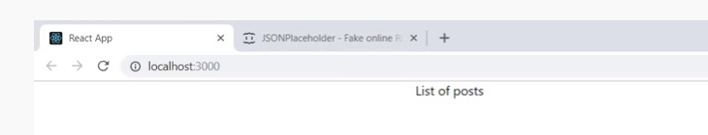

**Now get the data fetching..**

**S1- define the constructor using the key word –rconst**

**S2-post :[] –an empty array**

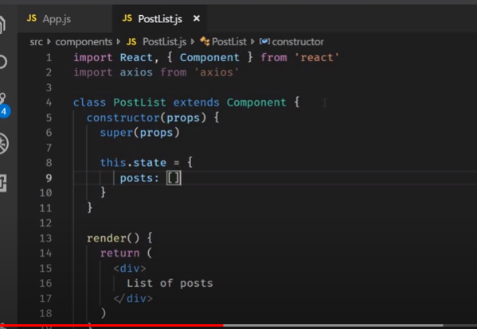

**S3- where we have to place the code to make the get request**

**In the componentDidMount Life Cycle Method- its execute only one time**

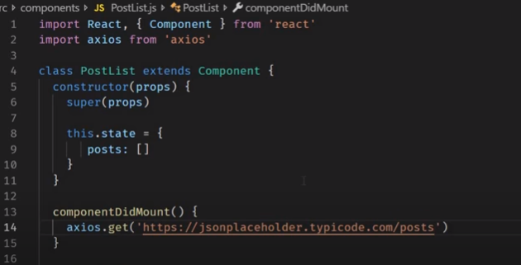

**From place holder get the url:-**

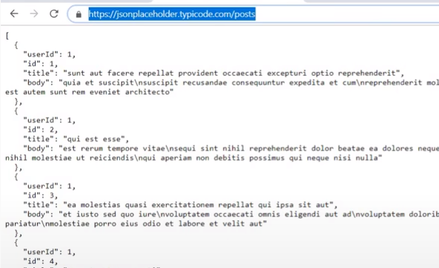

**How do we access the data that is return**

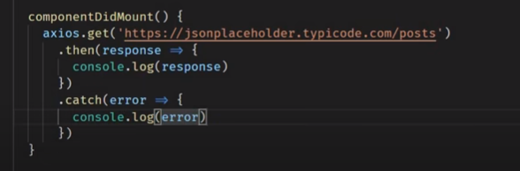

**Now run the app – inspect- log in the console –object-expand the data property**

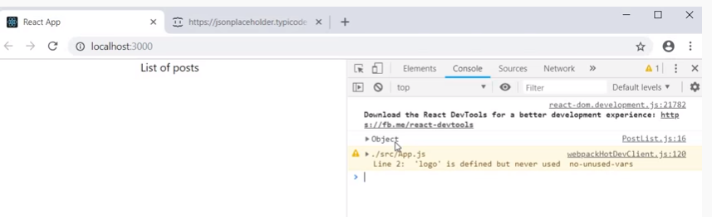

**List of posts.**

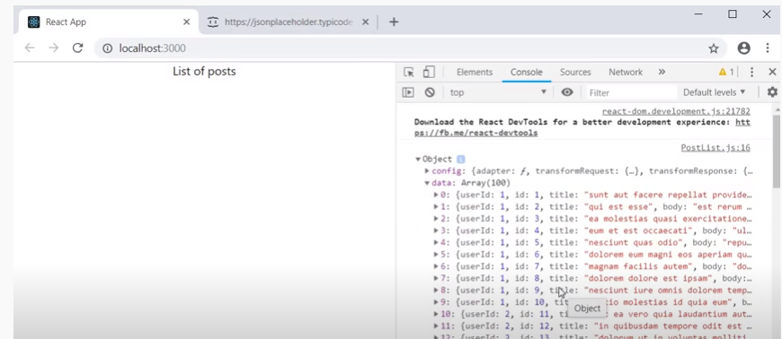

**Now render in jsx.**

**Add this.setState()----**

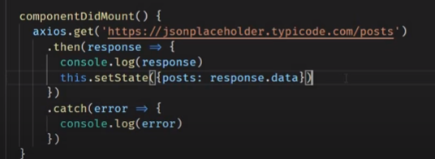

**In render method**

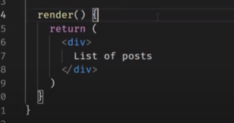

**Define**

* **this.state**
* **posts.length?**
* **post.map()**

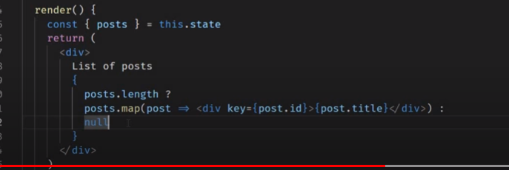

**Save and go back to browser :-**

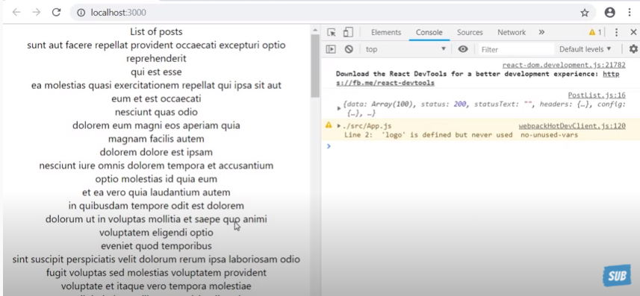

**Flow**

**F1-empty arrow**

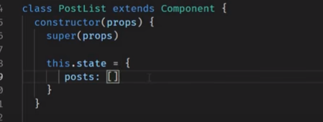

**F2- render method – List of posts is display but posts is empty array-control goes to**

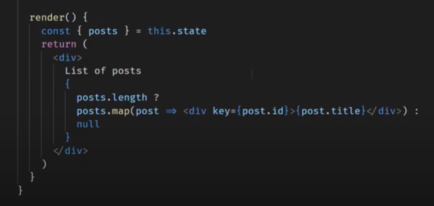

**List of posts is display but posts is empty array-control goes to get() -request**

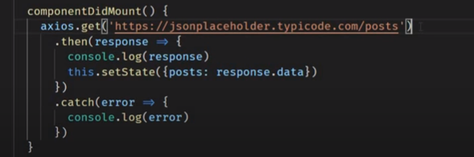

**// final render the list of post**

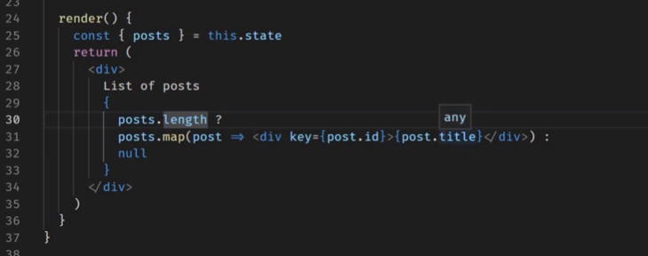

**Error message**

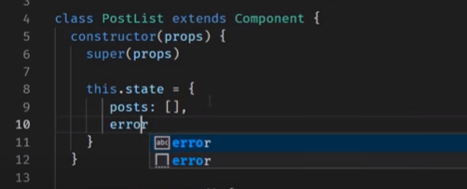

**Define the error message as String**

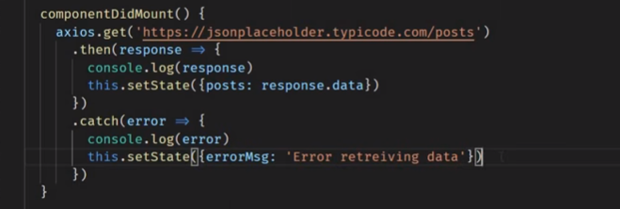

**If any error message then display –render – conditional defined errorMsg?**

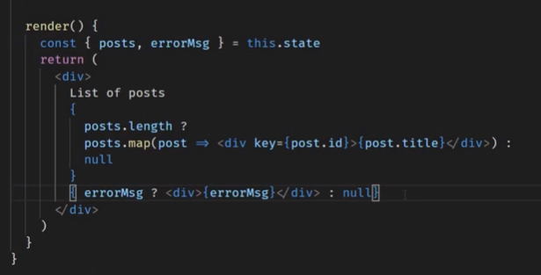

**Edit the url**

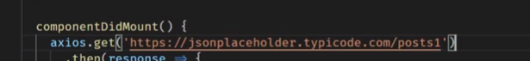

**In browser:-**

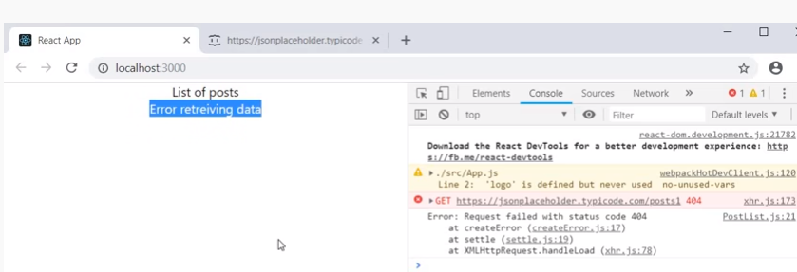

[**https://www.youtube.com/watch?v=x9UEDRbLhJE&list=PLC3y8-rFHvwgg3vaYJgHGnModB54rxOk3&index=43**](https://www.youtube.com/watch?v=x9UEDRbLhJE&list=PLC3y8-rFHvwgg3vaYJgHGnModB54rxOk3&index=43)

**post data from api**

**user id, id title, body.**

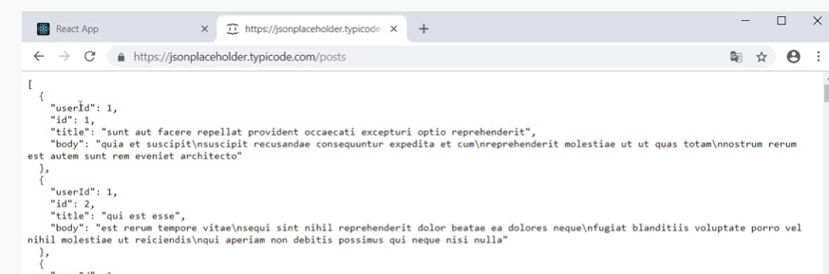

**Create the class –rec – Postform.js**

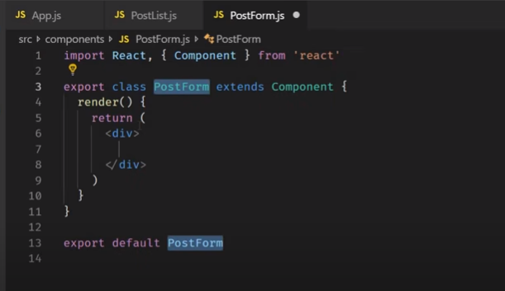

**Lets define the input values for user id, title and body.**

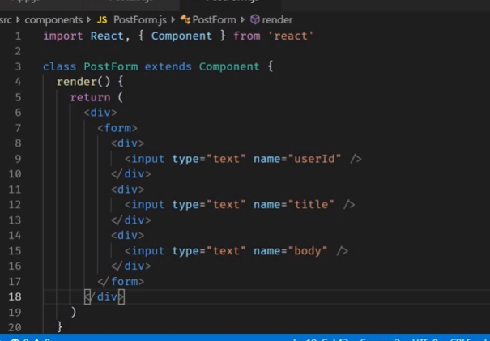

**Lets create state properties for these input elements and link back to these input elements**

* **rconst –for constructor**
* 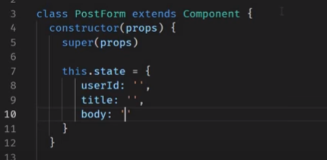

**Re-structure the render method : -**

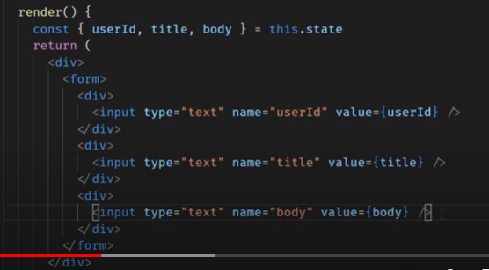

**Define the changeHandler**

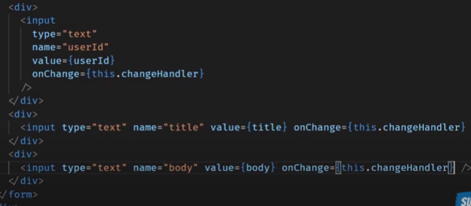

**S2- define changeHandler**

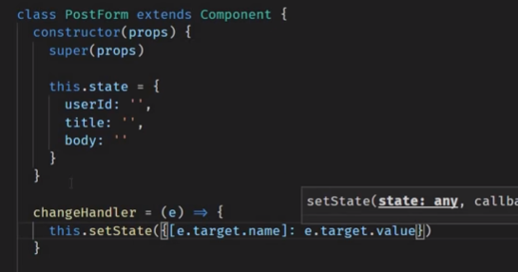

**As we to define submit Handler**

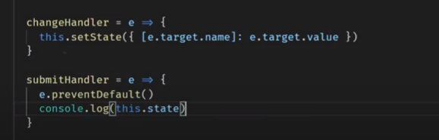

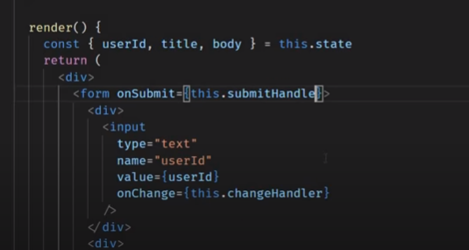

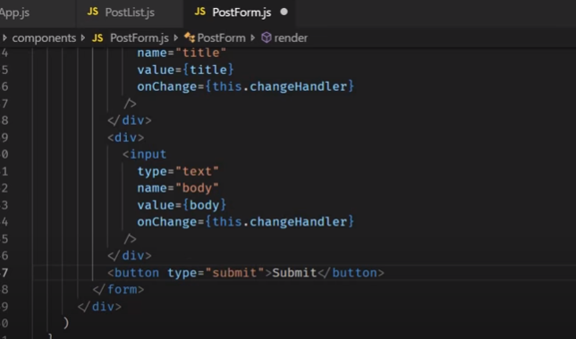

**Go back to App.js –define postfrom.**

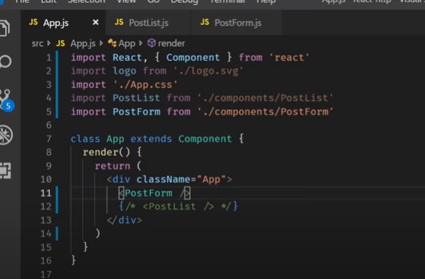

**Go back to the browser : -**

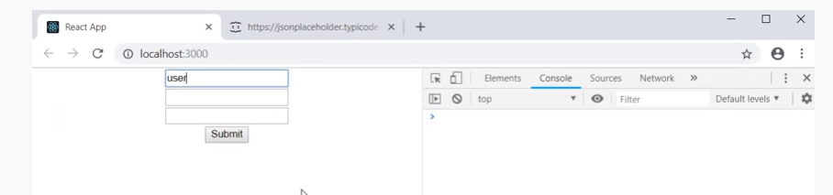

**Define some values**

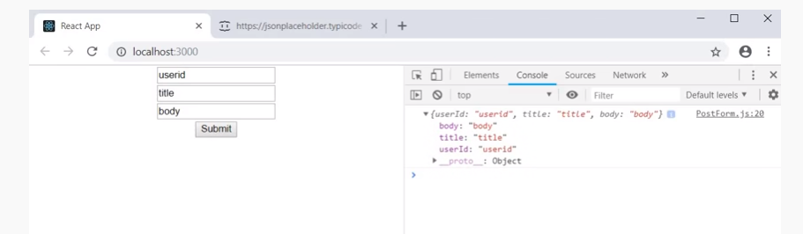

**Lets make few changes..**

**Import axios**

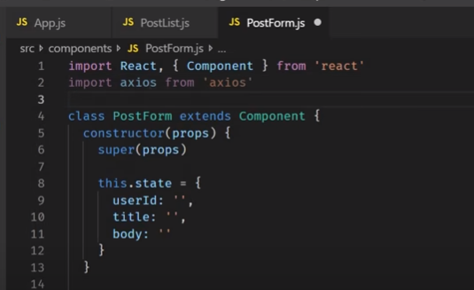

**In submitHandler**

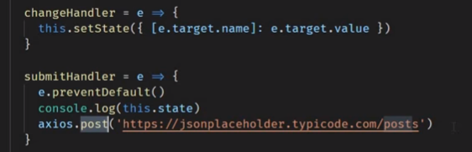

**Define the this.state and render on the browser is console.log(response)**

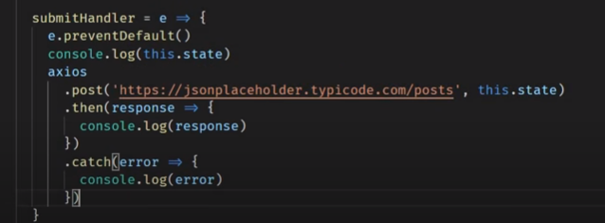

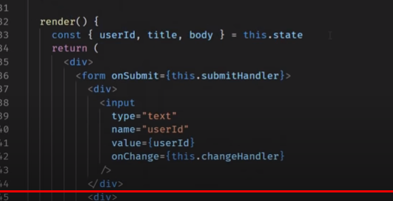

**Go back the browser –end**

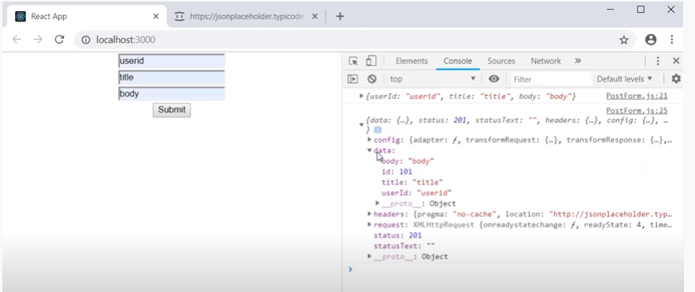

**Assignment making quite or delete request**

**Watch**

# React Axios CRUD with JSON SERVER | ReactJS Axios REST API | React Tutorials for Beginners

[**https://www.youtube.com/watch?v=59z1_3-vTOk**](https://www.youtube.com/watch?v=59z1_3-vTOk)

Watch the videos

<https://www.youtube.com/watch?v=06yVj8pcO5c&list=PLTP3E5bPW7944Ec1lfXzavqRHzxY5FigD>